2.54 cm

**AI-Powered Tutoring for Conceptual Clarity in Energy and Momentum among Malaysian Matriculation Physics Students**

Shafiq Bin Rasulan 1

*1 Kolej Matrikulasi Sarawak*

*E-mel ketua penyelidik*

**ABSTRAK**

*Patah perkataan tidak melebihi 200 patah; format italic bersaiz 12; dan justified*. *Jika kertas kajian ditulis dalam Bahasa Melayu, maka abstrak hendaklah ditulis dalam Bahasa Melayu. Jika kertas kajian ditulis dalam Bahasa Inggeris, maka abstrak hendaklah ditulis dalam Bahasa Inggeris*

*Kata Kunci : Tiga hingga lima patah perkataan*

# **PENDAHULUAN**

Langkau satu baris

Indent 1 cm

Latar belakang, pengalaman PdP, tujuan/ kepentingan, andaian, nilai dan kepercayaan pengkaji terhadap PdP dan lain-lain berkaitan

Langkau satu baris

* 1. Latar Belakang

# **2.0 REFLEKSI AMALAN /PDP LALU**

Over the past few semesters teaching Physics at the Malaysian Matriculation level, I have observed a recurring pattern of conceptual confusion among students, particularly in the topics of energy and momentum. Despite covering the syllabus thoroughly using standard lecture-based approaches and problem-solving tutorials, many students continued to display fundamental misconceptions. For instance, some believed that heavier objects always have more momentum regardless of velocity, while others misinterpreted energy as something that gets "used up" during a process, indicating a disconnect between instruction and conceptual internalisation.

One strategy I implemented in response was the use of formative assessments such as quizzes and short written explanations, designed to reveal students' thinking. While these activities provided insight into students’ misunderstandings, the challenge was responding effectively and promptly to each student's needs in a large class setting. The lack of immediate, individualized feedback limited my ability to engage students in meaningful conceptual dialogue — a key factor in promoting sensemaking and conceptual change (Author, Year).

I also encouraged peer discussions and group problem-solving, which helped to some extent. However, the discussions often reinforced superficial reasoning when misconceptions went unchallenged. The limitations in student responsiveness and the constraints of face-to-face class time highlighted the need for a more adaptive and scalable support system — one that could respond to each student's reasoning in real time (Author, Year).

Initial data gathered from diagnostic assessments — particularly items adapted from the Energy and Momentum Conceptual Survey (EMCS) — confirmed that a significant proportion of students held incorrect or incomplete mental models. In a pre-intervention diagnostic test administered to 40 students, only 35% correctly answered items related to momentum conservation in inelastic collisions, and less than 30% correctly explained energy transformation in closed systems. Additionally, qualitative responses from reflective journals showed that students struggled to relate the equations to real-world phenomena.

These reflections underscored the need to integrate tools that can offer immediate, dialogic feedback tailored to each learner’s thought process. AI tools such as ChatGPT and Gemini present an opportunity to fill this pedagogical gap by providing Socratic-style tutoring, encouraging self-explanation, and sustaining cognitive engagement beyond classroom hours (Author, Year). The integration of such tools, therefore, emerged not as a replacement for teaching, but as a necessary extension of it — to enhance conceptual understanding and support responsive teaching at scale.

Teaching physics at the Malaysian Matriculation level has consistently revealed a tension between curriculum coverage and deep conceptual understanding. Despite completing syllabus content on time and employing structured tutorials, I observed that many students were still unable to grasp the underlying principles of energy and momentum. These issues persisted even among students who could solve numerical problems mechanically. This indicated a disconnect between algorithmic proficiency and conceptual understanding — a common phenomenon in physics education (Author, Year).

Formative assessments, such as exit tickets and conceptual quizzes, were used regularly to identify misconceptions. In one quiz focused on inelastic collisions, 65% of students incorrectly stated that kinetic energy is conserved during the collision. When asked to explain energy transfer in a pendulum system, 70% of students gave responses that suggested energy is “used up” at the highest point, rather than transformed between kinetic and potential forms. These formative results signaled the prevalence of naive conceptions among learners.

In addition to quantitative data, student reflections collected via journals and anonymous surveys revealed key insights. Several students expressed uncertainty or discomfort when faced with conceptual questions:

*“I memorized the formulas, but when the question asked ‘why’ something happens, I didn’t know how to explain it.”*

*“Sometimes I think I understand, but when I try to explain it, I get confused again.”*

*“Discussions help me sometimes, but I’m afraid of giving wrong answers in class.”*

These reflections highlight two interrelated problems: students’ difficulty articulating their thinking, and the lack of a low-stakes, responsive platform for conceptual exploration. Although I incorporated peer discussions into the lessons, these were not always effective at addressing misconceptions. In many cases, incorrect ideas were reinforced when peers were equally uncertain. My own attempts to offer feedback during class were constrained by time, resulting in missed opportunities for targeted conceptual intervention.

The need for an individualized, dialogue-based support system became increasingly clear. AI tools such as ChatGPT and Gemini, which can simulate Socratic questioning and provide feedback based on student input, emerged as potential solutions. Their ability to engage students in real-time, explain complex ideas conversationally, and adjust explanations based on follow-up questions makes them uniquely suited to address the challenges I encountered. These AI tools do not replace the role of the teacher, but they offer a scalable way to extend responsive teaching beyond the classroom and personalize the learning experience (Author, Year).

**Early Diagnostic Data**

Below is an outline of early diagnostic data collected before the intervention, which supports the need for change:

**Table 1.** Pre-test Results

|  |  |  |
| --- | --- | --- |
| **Conmceptual Area** | **Correct Response Rate** | **Common Misconceptions** |
|  |  |  |
|  |  |  |
|  |  |  |

These data further confirmed the importance of addressing students' underlying reasoning processes, not just their ability to recall formulas.

# **`3.0 FOKUS KAJIAN / ISU KEPRIHATINAN**

This study focuses on students’ conceptual difficulties in the topics of energy and momentum within the Malaysian Matriculation Physics curriculum. These two fundamental concepts were selected based on both classroom observations and diagnostic data that consistently pointed to deep-rooted misconceptions. Students frequently misinterpret energy as something that is consumed or depleted, rather than transferred or transformed within a system. Similarly, momentum is often misunderstood, with students conflating it with either force or mass alone, leading to incorrect predictions in collision-related problems. These conceptual gaps hinder students’ ability to reason through physical phenomena and apply principles meaningfully across contexts.

The focus of the study is directly aligned with the learning needs of the students, as highlighted in pre-intervention assessments and personal reflections. Student feedback further supports this emphasis; many learners reported struggling to explain energy conservation in everyday contexts or to differentiate between momentum and inertia. These difficulties are not just isolated to a few individuals but are common across the cohort, making the issue both urgent and significant.

In selecting this focus, three criteria were considered: importance, feasibility, and relevance. The importance of these concepts lies in their foundational role within classical mechanics and their prominence in examinations, making mastery essential for academic progression and scientific literacy. From a feasibility standpoint, the topics align with the current teaching semester and can be seamlessly integrated into the existing instructional timeline. Furthermore, the proposed intervention using AI tools such as ChatGPT and Gemini is practical, as it requires minimal infrastructure and can be accessed by students outside the classroom, allowing for flexible and scalable support. Relevance is also a key factor; the early data and student reflections clearly show that these misconceptions are widespread and persistent. The intervention, therefore, responds directly to real and documented learning difficulties rather than theoretical assumptions.

By narrowing the scope to energy and momentum, this study aims to address both conceptual and pedagogical challenges. It seeks not only to improve students’ understanding of specific content areas but also to explore how AI-based dialogue can serve as a tool for individualized sensemaking in physics education. The targeted nature of the focus ensures that the action taken is meaningful, manageable, and reflective of the students' actual learning experiences.

# **4.0 OBJEKTIF KAJIAN**

Indent 1 cm

Objektif kajian selari dengan fokus kajian, realistik, boleh diukur dan dinyatakan dengan jelas.

# **5.0 KUMPULAN SASARAN**

Kumpulan sasaran terdiri daripada pelajar Sistem Dua Semester Program Matrikulasi KPM Sesi 2022/2023. Kumpulan pelajar ini mendapat sekurang-kurangnya C pada peperiksaan SPM yang lepas.

Pemilihan kumpulan sasaran: tepat dan selari dengan masalah/ fokus kajian. Cara pemilihan dinyatakan. Penjelasan kumpulan sasaran, iaitu jantina, bangsa dan latar belakang akademik.

# **6.0 PELAKSANAAN TINDAKAN**

Tindakan/ Aktiviti PdP (Penggunaan bahan/ aktiviti, strategi pengajaran, inovasi/ kreativiti dan justifikasi). Menggunakan model yang sesuai untuk memperkenalkan tindakan/ intervensi.

# **7.0 PEMERHATIAN DAN DAPATAN KAJIAN**

Pengumpulan dan analisis data serta perbincangan dapatan. Format rajah dan jadual seperti berikut:

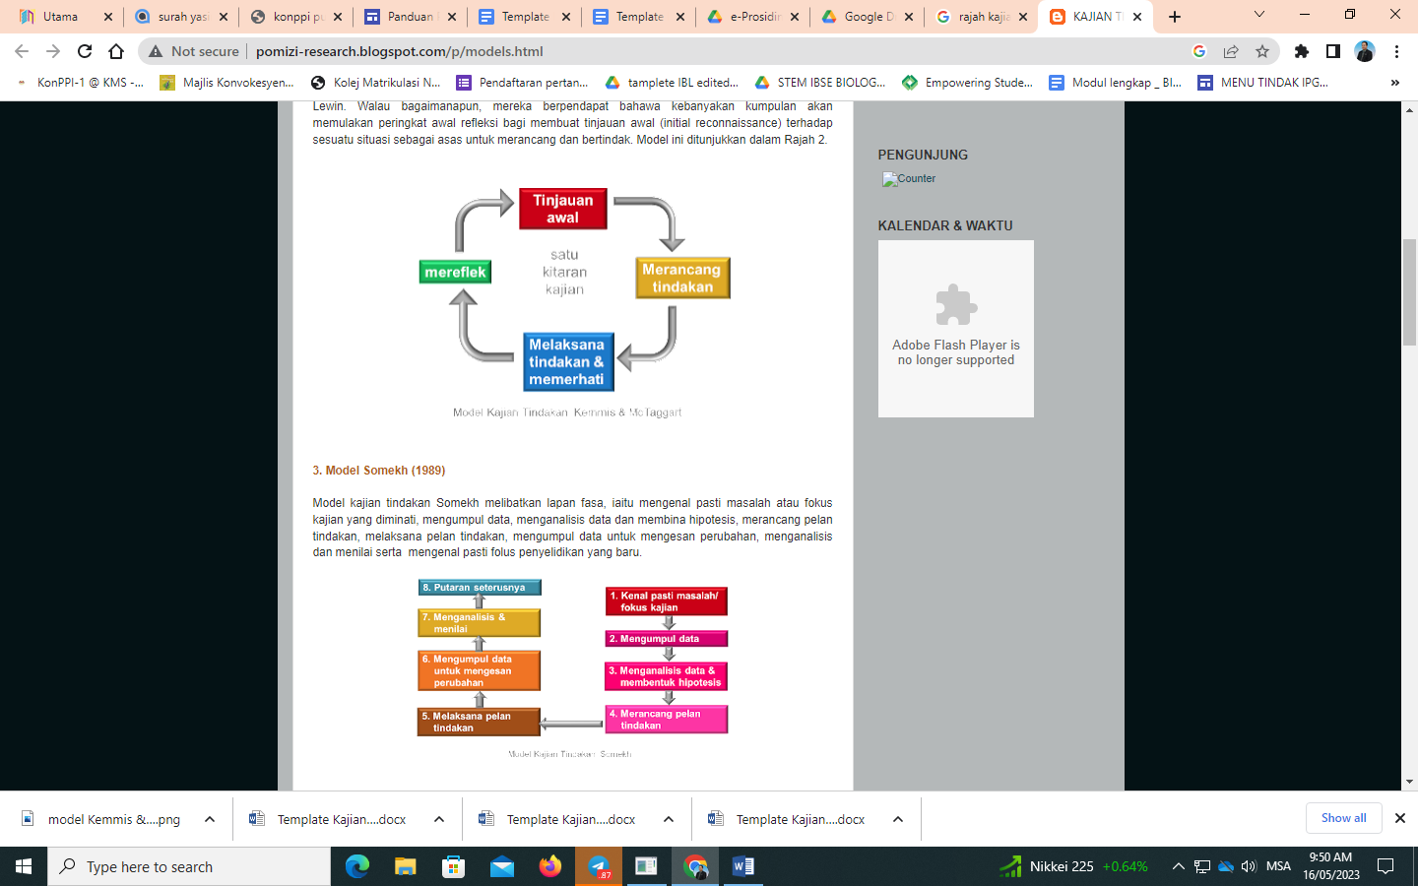

**Rajah 1.** Model Kajian Tindakan Kemmis & Mc Taggart

**Jadual 1.** Perbezaan markah A dengan B

|  |  |  |  |
| --- | --- | --- | --- |
| **Sampel** | **Markah A** | **Markah B** | **Perbezaan** |
|  |  |  |  |
|  |  |  |  |
|  |  |  |  |

# **8.0 REFLEKSI DAN KESIMPULAN**

Penerangan perubahan. Kekuatan dan kelemahan kajian, pencapaian objektif serta keberkesanan tindakan/ aktiviti. Membuat penilaian terhadap intervensi/ kekuatan dan kelemahan kajian, pencapaian objektif dan keberkesanan tindakan/ aktiviti. Cadangan kajian lanjutan.

# **PENGHARGAAN**

# **RUJUKAN**

Mengikut format gaya penulisan APA (*American Physiological Association*) edisi terkini.

# **LAMPIRAN**